# Imagen que contiene Icono Descripción generada automáticamente5UNIVERSIDAD AUTONOMA DE COAHUILA CENTRO DE IDIOMAS US



**1ST TEST**

LEVEL 5 KIDS

# STUDENT´S NAME: DATE: TEACHER´S NAME: WRITTEN GRADE ORAL GRADE

**Listening**

5. **LISTEN AND NUMBER. ** **115**

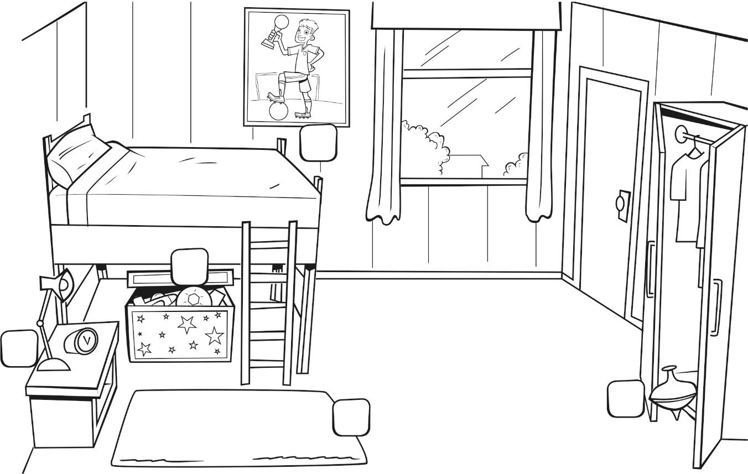

**/ 10 points**

# LOOK, READ, AND MATCH.

**Reading**

**1 **  **A**

**2 **  **B**

**3 **  **C**

**4  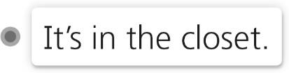 D**

**5 **  **E**

**/ 10 points**

**Vocabulary**

1. READ AND WRITE.

**Lizard mouse owl alligator tortoise**

|  |  |  |
| --- | --- | --- |
|  |  |  |
| a | an | a |
|  |  |  |
| a | an | **/ 10 points** |

1. WRITE THE ANIMALS WITH ***A*** OR ***AN***.

**Otter butterfly bee spider ant**

|  |  |  |  |  |  |
| --- | --- | --- | --- | --- | --- |
| 1 |  | 2 |  | 3 |  |
|  | What is it?  **It’s**  **.** |  | What is it?  **It’s**  **.** |  | What is it?  **It’s**  **.** |
| 4 |  | 5 |  |  |  |
|  | What is it?  **It’s**  **.** |  | What is it?  **It’s**  **.** |  | **TOTAL / 10** |

**Writing**

# DRAW YOUR BEDROOM AND WRITE A SHORT DESCRIPTION.

**/ 10 points**

**Total points 50**